[CS250-Data-Structures](https://github.com/Rachels-Courses/CS250-Data-Structures)/[Assignments](https://github.com/Rachels-Courses/CS250-Data-Structures/tree/2017-01-Spring/Assignments)/[Extra-credit](https://github.com/Rachels-Courses/CS250-Data-Structures/tree/2017-01-Spring/Assignments/Extra-credit)/[STL-List](https://github.com/Rachels-Courses/CS250-Data-Structures/tree/2017-01-Spring/Assignments/Extra-credit/STL-List)/**README.md**

**STL List Lab**

[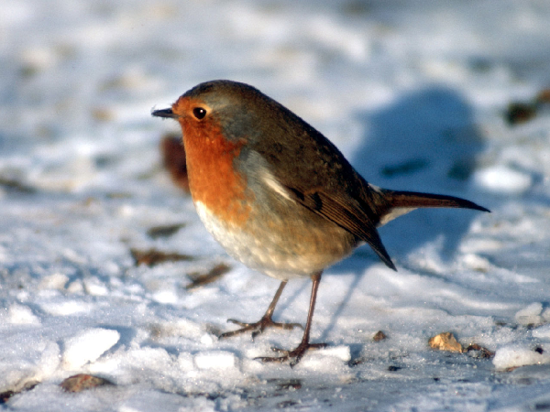](https://github.com/Rachels-Courses/CS250-Data-Structures/blob/2017-01-Spring/Assignments/Extra-credit/STL-List/bird.png)

**Introduction**

Read this in Chrome! :)

This lab is a simple example of using an STL List and iterating through it.

Unlike an STL vector, we cannot *randomly* access elements of the STL List - we must iterate through each element.

We can do this with Iterators in C++. This lab will step through how to do this.

**Turn-in**

Upload your **.cpp**, **.hpp** (or **.h**) files.

**Group Work Policy**

* Group work and/or collaboration is allowed for this assignment.
* You are allowed to research on the internet.
* You are allowed to ask the instructor for help.

**Setup**

Make sure to download the following files:

* bird.ppm

You can also create your own image file to edit. In GIMP, export as .ppm, and make sure to save it as an ASCII file.

**Reference**

[C++ Reference - List](http://www.cplusplus.com/reference/list/list/)

**Writing the program**

Include the following headers at the beginning of your program:

#include <iostream>

#include <fstream>

#include <list>

#include <string>

fstream is for file input/output - we will be reading in an image file and writing an image back out.

In main, you will want to create a list of integers - name this variable **colors**. Each pixel of the image is stored as a color value, which is what we're reading in.

**Reading in the image**

Create an **ifstream** object, and load in the "bird.ppm" file.

The image file has a header before the actual image data, which looks like:

P3

# CREATOR: GIMP PNM Filter Version 1.1

600 450

255

we want to save this header for later - so you should create a string to store the header.

You can use **getline** to read in lines of text from the image file. See the solution below if you aren't very familiar with File I/O.

**Opening the file and saving the header**

ifstream input( "bird.ppm" );

string buffer;

string header;

// Save the header:

getline( input, buffer ); // ascii code

header += buffer + "\n";

getline( input, buffer ); // comment

header += buffer + "\n";

getline( input, buffer ); // width/height

header += buffer + "\n";

getline( input, buffer ); // max color

header += buffer + "\n";

After the header, all the contnets of the file are integers representing colors, each on their own line. Create a temporary variable called **color** to store these numbers in, and then iterate through everything in the file, storing each color in the colors list.

**Iterating through the file, storing in a list**

<pre>

int color;

while ( input >> color )

{

colors.push_front( color );

}

</pre>

Make sure to close the input file once done.

Note that for the code above, push_front is being used. We can also use push_back with the List. As it is right now, the list will be reversed when we output it back to a file.

**Writing out a modified image**

Create an **ofstream** object to output a new image file (name it something besides bird.ppm, but still something with .ppm at the end.)

First, make sure to output the header to the file.

Then, use a for loop and an iterator to output each color to the file.

Close the file once done.

**Iterating through the list of colors**

<pre>

ofstream output( "bird2.ppm" );

output << header;

for ( list<int>::iterator it = colors.begin();

it != colors.end();

it++ )

{

output << *it << endl;

}

output.close();

</pre>

Run the program and view the resulting image file.

(Note: It might take the program a while to write out the result)

**More changes**

If you open up the .ppm file in a text editor, you will see values like this:

P3

# CREATOR: GIMP PNM Filter Version 1.1

600 450

255

221

221

...etc...

If you've worked with HTML and CSS, you might remember that colors are represented as hex numbers: #FF0000 is red, #00FF00 is green, and #0000FF is blue.

Each three sets of numbers represent red, green, and blue in this file.

You can use this information to make other changes...

**flipped.ppm**

[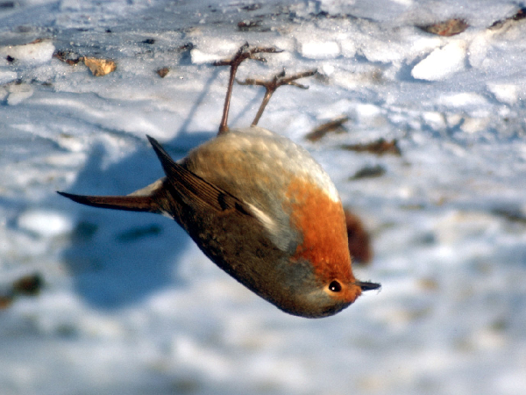](https://github.com/Rachels-Courses/CS250-Data-Structures/blob/2017-01-Spring/Assignments/Extra-credit/STL-List/flipped.png)

Flip the bird image without changing the colors - remember that colors come in groups of 3. You might want to modify your color input code to something more like this:

int r, g, b;

while ( input >> r >> g >> b )

{

colors.push_back( r );

colors.push_back( g );

colors.push_back( b );

}

Experiment by creating a second list of integers, and push the r, g, b values to the "colorsBackwards" list in a different order so that, when it's output back, you get an upside-down bird.

**removecolor.ppm**

[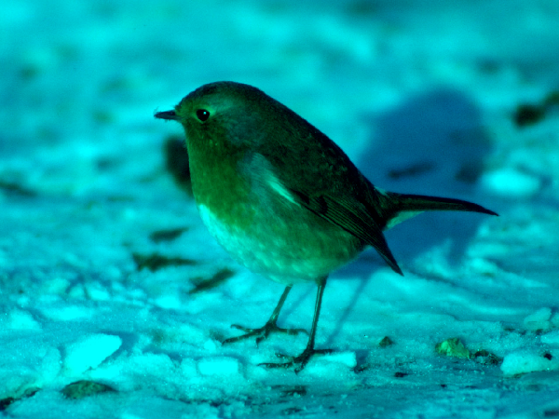](https://github.com/Rachels-Courses/CS250-Data-Structures/blob/2017-01-Spring/Assignments/Extra-credit/STL-List/removecolor.png)

For this image, remove **one** color from the image by replacing it with 0.

Remember that the colors come in groups of 3, so you can use a counter and the modulus operator to set each 3rd item to output "0" instead of the actual color.

**halfcolor.ppm**

[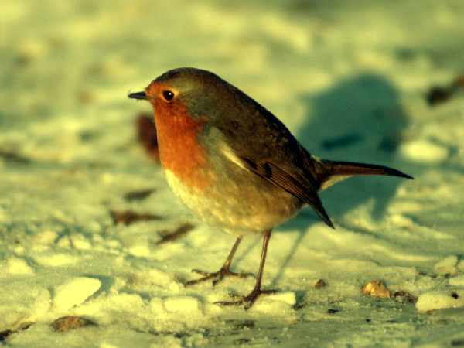](https://github.com/Rachels-Courses/CS250-Data-Structures/blob/2017-01-Spring/Assignments/Extra-credit/STL-List/halfblue.png)

For this image, remove **one** color from the image by replacing it with 0.

Remember that the colors come in groups of 3, so you can use a counter and the modulus operator to set each 3rd item to output half the current color instead of the actual color. The image above is halving the blue values.